

**Tribhuvan University**

**Faculty of Humanities and Social Sciences**

**A PROJECT REPORT**

**“Cakeria”**

**Submitted to**

**Department of Computer Application**

**Hetauda School of Management and Social Science**

**In partial fulfillment of the requirements for the Bachelor’s in Computer Application**

**Submitted by**

Rijan Shrestha Taujale

**Under the Supervision of**

Mr. Sujan Devkota



**Tribhuvan University**

**Faculty of Humanities and Social Sciences**

**Hetauda School of Management and Social Science**

# Supervisor’s Recommendation

I hereby recommend that this project prepared under supervision by **Mr. Rijan Shrestha Taujale** entitled “**Cakeria”** in partial fulfillment of the requirements of Fourth Semester (Project I) for the degree of Bachelor of Computer Application is recommended for the final evaluation.

……………………

SIGNATURE

Mr. Sujan Devkota

SUPERVISOR

Department of Computer Application

Hetauda School of Management and Social Science

Hetauda-4, Makwanpur,Nepal



**Tribhuvan University**

**Faculty of Humanities and Social Sciences**

**Hetauda School of Management and Social Sciences**

# LETTER OF APPROVAL

This is to certify that this project prepared by **Mr. Rijan Shrestha Taujale** and entitled “**Cakeria”** in partial fulfillment of the requirements of Fourth Semester (Project I) for the degree of bachelor’s in computer application has been evaluated. In our opinion it is satisfactory in the scope and quality as a project for the required degree.

|  |  |
| --- | --- |
| **SIGNATURE of Supervisor**  Mr. Sujan Devkota  Department of Computer Application  Hetauda-4, Makwanpur, Nepal | **SIGNATURE of Coordinator** |
| **SIGNATURE of Internal Examiner** | **SIGNATURE of External Examiner** |

# Acknowledgement

I am grateful to everyone who contributed to the completion of this project. Firstly, we extend our heartfelt thanks to Hetauda School of Management and Social Science for providing us with invaluable resources, unparalleled guidance, and an enriching learning environment. It is through their unwavering support that I was able to delve into our research and acquire knowledge that shaped the project's outcomes.

Our gratitude extends to our esteemed project coordinator, Mr. Sujan Devkota, whose constant support and insightful guidance played a pivotal role in steering this project towards success. His wisdom and astute feedback significantly influenced the direction and development of our work, for which I am deeply thankful.

I owe a profound debt of gratitude to our instructors and mentors. Without their tireless efforts and encouragement, navigating through the complexities of this project would have been an insurmountable challenge. Their steadfast support fueled our determination to strive for excellence.

Lastly, I express our deepest gratitude to our families. Their love, patience, and support sustained us through every stage of this project, giving us the strength to persevere.

In conclusion, I sincerely thank everyone who contributed to this project. Your help and encouragement have been invaluable, and I are truly grateful for this opportunity.

Your Sincerely,

Rijan Shrestha Taujale

# Abstract

Many people enjoy cakes for celebrations or personal indulgence, which significantly contributes to creating memorable moments and enhancing happiness. However, finding the desired type or design of cake can often be a challenge, especially when local bakeries have limited options. The main aim of this web development project is to create an online platform, Cakeria, that offers a wide range of cakes for various occasions, available for purchase and delivery straight to the customer's doorstep. This comprehensive web application is designed to provide cake enthusiasts with an extensive selection of cakes to choose from, ensuring they find exactly what they’re looking for.

In addition to offering a variety of cakes, the platform allows customers to easily add multiple cakes to their cart for bulk purchases and provides a streamlined ordering process. It features separate dashboards for customers and administrators, enabling smooth management of orders and products. The admin can update, add, or delete products and set the status of orders as canceled or successful. Cakeria aims to simplify the process of ordering cakes, providing a one-stop solution for cake lovers. By combining a diverse selection of cakes with efficient management tools, this online platform seeks to be the ultimate destination for both customers and bakery administrators, making the experience of ordering and managing cakes enjoyable and stress-free.

**Table of Contents**

Supervisor’s Recommendation 2

LETTER OF APPROVAL 3

Acknowledgement 4

Abstract 5

Chapter 1: Introduction 9

1.1 Introduction: 9

1.2 Problem Statement: 9

1.3 Objectives: 10

1.4 Scope and Limitations: 11

1.4.1 Scopes: 11

1.4.2 Limitations: 11

1.5 Report Organization: 12

Chapter 2: Background Study and Literature Review 13

2.1 Background Study 13

2.2 Literature Review 13

Chapter 3: System Analysis and Design 15

3.1 System Analysis 15

3.1.1 Requirement Analysis 15

Figure 3.1: Use Case Diagram 15

3.1.2 Feasibility Analysis 16

Figure 3.2: Gantt Chart of Cakeria 17

3.1.3 Data Modeling 18

3.1.4 Process Modeling 19

Figure 3.4: Context Level Diagram 19

Figure 3.5: Level 1 DFD 19

Figure 3.6: Level 2 DFD 20

3.2 System Design 21

3.2.1 Architectural Design 21

Figure 3.7: Architectural Design 21

Figure 3.8: Database Schema Diagram 22

3.2.2 Interface Design 23

Figure 3.2.2.1: User Login 23

Figure 3.2.2.2: User Dashboard 23

Chapter 4: Implementation and Testing 24

4.1 Implementation 24

4.1.1 Tools Used 24

4.1.2 Implementation of Module 25

4.2 Testing 26

4.2.1 Test Case for Unit Testing 26

4.2.2 Test Case for System Testing 32

Chapter 5: Conclusion and Future Recommendation 34

5.1 Lesson Learnt and Outcome 34

5.2 Conclusion 35

5.3 Future Recommendations 35

Appendices 37

Figure 1: Admin Login 37

Figure 2: Admin Dashboard 37

Figure 3: Admin Manage Products 38

Figure 4: Admin Change Credentials 38

Figure 5: Admin Manage Orders 39

Figure 6: User Login 39

Figure 7: User Register 40

Figure 8: User Dashboard 40

Figure 9: User View Products 41

Figure 10: User Cart 41

Figure 11: User Order Confirmation 42

References 43

**List of Abbreviations**

|  |  |
| --- | --- |
| **Keywords** | **Full Form** |
| CSS | Cascading Stylesheet |
| DFD | Data Flow Diagram |
| ER | Entity Relationship |
| HTML | Hyper Text Markup Language |
| OS | Operating System |
| PHP | Hyper Text Preprocessor |
| RAM | Random Access Memory |
| SQL | Structured Query Language |
| UI | User Interface |
| VS | Visual Studio |
| XAMPP | X-operating system, Apache, MySQL, PHP, Perl |

# Chapter 1: Introduction

## Introduction:

Cakeria is a simple online platform designed to make ordering cakes easier for everyone. Whether it’s for a birthday, a wedding, or any special event, customers can use Cakeria to easily find and order cakes. The platform allows users to browse different cake options, customize them with flavors and toppings, and track the delivery of their order.

This project aims to provide an easy-to-use system that helps customers get the perfect cake for their needs. At the same time, it helps bakeries manage their orders and deliveries, making it easier for them to run their businesses.

In this report, we will discuss the features of Cakeria, including cake browsing, customization, and delivery tracking. We will also look at how the platform helps bakery owners manage orders efficiently. This project is a great way to explore the basics of web development and e-commerce systems.

## Problem Statement:

Many existing cake ordering platforms lack intuitive navigation and efficient order management, making it difficult for customers to browse and purchase cakes. Additionally, bakery owners struggle to manage product listings, track orders, and oversee the overall system effectively. The key challenges include:

* **Complex ordering process:** Customers find it difficult to search for and order cakes efficiently.
* **Limited cart functionality:** Many platforms do not allow users to add multiple items to their cart and purchase them together.
* **Ineffective admin management:** Admins face challenges in adding, updating, or removing products from the system.
* **Poor order tracking:** Customers cannot easily check their order status, and admins lack a streamlined way to manage orders.
* **Lack of clear dashboards:** Both customers and admins need dedicated dashboards for a smoother experience.
* **Security concerns:** The absence of secure authentication mechanisms can pose risks to user data.

Cakeria addresses these issues by providing a user-friendly platform where customers can seamlessly browse, add multiple cakes to their cart, and complete purchases. Admins have full control over product listings and order management through a dedicated dashboard.

## Objectives:

To resolve these issues, Cakeria aims to:

* **Simplify cake ordering:** Provide an intuitive interface for customers to browse, search, and order cakes effortlessly.
* **Support multiple-item purchases:** Enable customers to add multiple cakes to their cart and buy them in a single transaction.
* **Enhance admin control:** Allow admins to efficiently add, update, or remove cakes from the platform.
* **Improve order tracking:** Give admins the ability to update order statuses as successful, canceled, or deleted, while allowing customers to track their orders easily.
* **Offer dedicated dashboards:** Provide separate, user-friendly dashboards for customers and admins to enhance navigation and functionality.
* **Ensure secure authentication:** Implement a secure login system where both admins and customers can log in safely, with admins having the ability to change their credentials.

## Scope and Limitations:

### Scopes:

The scope of Cakeria offers several opportunities for growth and improvement in the online cake ordering process:

* Expanding Market: Cakeria can expand to include different types of cakes, like wedding or birthday cakes, reaching more customers.
* Business Growth: Bakery owners can improve their operations by managing orders, products, and inventory easily through the platform.
* Better Customer Experience: The platform can improve customer satisfaction by making it easier to order cakes and offering a simple, user-friendly system.
* Future Updates: There is potential to add more features in the future, like delivery tracking and cake customization, to improve the platform further.

### Limitations:

While Cakeria provides an easy-to-use platform for ordering and managing cakes, it has a few limitations:

* No Delivery Tracking: The platform does not include a feature to track the delivery of orders.
* No Cake Customization: Customers cannot customize cakes according to their preferences.
* Limited Customer Access: Customers cannot update their login credentials; only admins have this ability.
* Focus on Cakes Only: The platform is designed specifically for cakes and does not support other bakery items.

## Report Organization:

* Chapter 1: "Introduction" - This chapter introduces the project, including the problem statement, objectives, and the scope of Cakeria.
* Chapter 2: "Background Study and Literature Review" - This chapter explains the background of the study and reviews related work or existing systems in the field.
* Chapter 3: "System Design" - This chapter covers the functional and non-functional requirements, system architecture, and feasibility analysis.
* Chapter 4: "Implementation and Testing" - This chapter describes the methods, tools, and techniques used to implement the project, along with the testing process and results.
* Chapter 5: "Conclusion and Future Enhancements" - This chapter concludes the project, highlighting its achievements and discussing potential future improvements or additions.

# Chapter 2: Background Study and Literature Review

## Background Study

Currently, the market lacks a well-integrated cake ordering platform like Cakeria, which addresses both customer and bakery needs. Existing platforms often fail to offer a variety of cake customization options, and bakeries find it difficult to manage orders efficiently. Customers face issues with the clarity of product specifications, including cake design, delivery options, and pricing transparency. Cakeria aims to resolve these issues by offering a smooth and engaging experience for both customers and bakers.

## Literature Review

The development of online platforms for cake ordering has been greatly influenced by advancements in e-commerce technologies and user interface design. Existing systems, such as BakeHub and CakeZone, provide basic online cake ordering services but often lack essential features like bulk purchasing or separate dashboards for customers and administrators. These shortcomings underline the need for a more comprehensive solution tailored to the needs of both customers and bakery owners.

Research on e-commerce trends has shown that user-friendly interfaces, secure payment gateways, and efficient order management systems are critical for ensuring customer satisfaction. Platforms that support multiple product purchases in a single transaction have proven to retain customers more effectively. Additionally, studies on order and inventory management emphasize that digital tools for tracking and managing products reduce manual errors and save time, enabling bakery businesses to operate more efficiently and focus on improving customer service.

Security and access control have also been highlighted as vital aspects of digital platforms. Secure login systems that provide robust access control for administrators while maintaining simplicity for customers are crucial for building trust and protecting user data. These insights from existing literature and systems have shaped the design and implementation of *Cakeria*, ensuring that it addresses current market gaps while offering an efficient and user-friendly solution for both customers and bakery owners.

# Chapter 3: System Analysis and Design

## System Analysis

### Requirement Analysis

* + - 1. Functional Requirements:
* Customers can browse cakes, add multiple items to their cart, and place orders.
* Admins can add, update, or delete products and manage order statuses (successful, canceled, or deleted).
* Secure login functionality for both customers and admins, with admin access to update credentials.
* Separate dashboards for customers and admins to streamline operations.

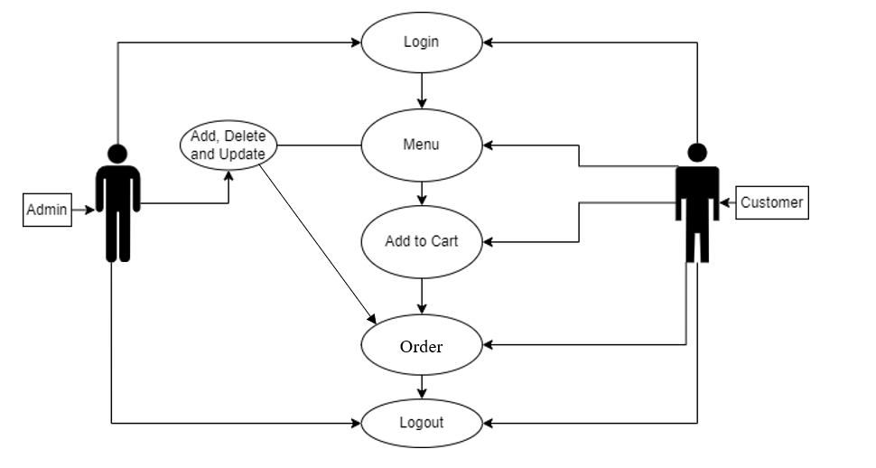

### Figure 3.1: Use Case Diagram

* + - 1. **Non-Functional Requirements:**
* Usability: The platform should have a simple, user-friendly interface for both customers and admins.
* Security: User data and transactions should be protected through secure login and data handling processes.
* Performance: The system should handle multiple users and transactions without noticeable delays.
* Reliability: The platform should operate smoothly with minimal downtime or technical issues.

### Feasibility Analysis

* + - 1. **Technical Feasibility:**

The platform is technically feasible as it utilizes widely available technologies such as PHP, MySQL, and web development frameworks. Using tools like XAMPP for local development ensures the project can be developed and tested effectively on a small scale before scaling up.

* + - 1. **Operational Feasibility**

The system is operationally feasible as it addresses specific challenges faced by customers and bakery owners. Its features simplify the ordering process for customers and improve product and order management for admins, making it practical for real-world implementation.

* + - 1. **Economic Feasibility**

The development of Cakeria involves minimal costs, leveraging free and open-source tools like XAMPP, PHP, and MySQL. The system’s potential to attract more customers and improve operational efficiency for bakery owners ensures a good return on investment.

* + - 1. **Schedule Feasibility**

By breaking down the project into well-defined tasks, Cakeria is expected to be completed within a 13-Week timeline. A Gantt chart helps monitor progress and manage project phases effectively.

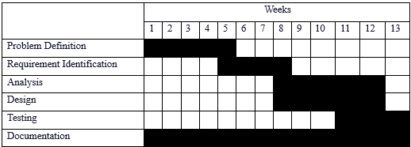

### Figure 3.2: Gantt Chart of Cakeria

### Data Modeling

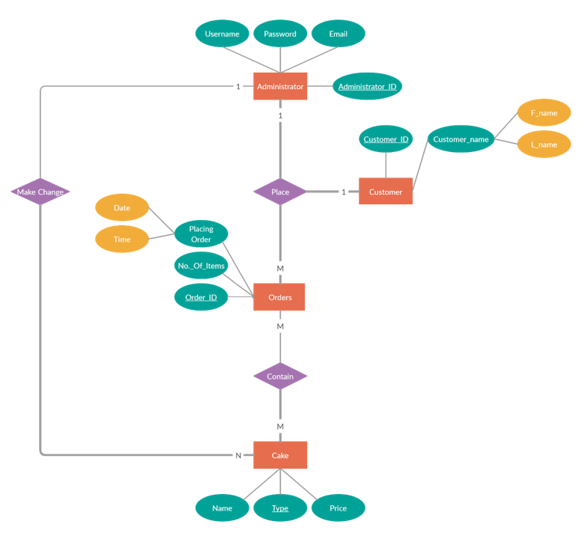

**Fig 3.3: ER Diagram**

### Process Modeling

* + - 1. **Context Level Diagram/ Level 0 DFD:**

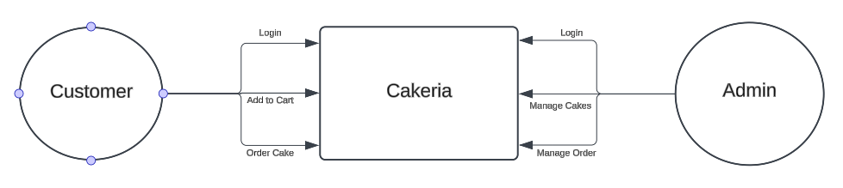

### Figure 3.4: Context Level Diagram

* + - 1. **Level 1 DFD:**

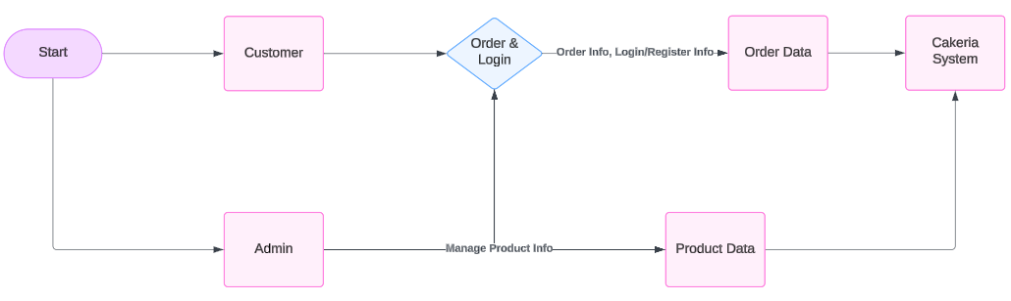

### Figure 3.5: Level 1 DFD

* + - 1. **Level 2 DFD:**

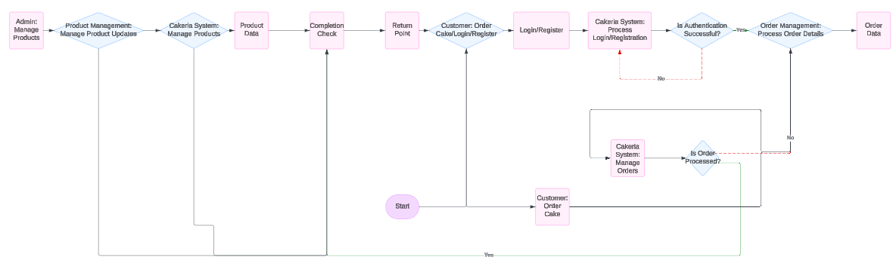

### Figure 3.6: Level 2 DFD

## System Design

### Architectural Design

The Architectural Design section typically serves as an overview of how the system is structured, its primary sub-systems, and the interactions between them. It lays the foundation for system development by organizing and detailing the relationships between components.

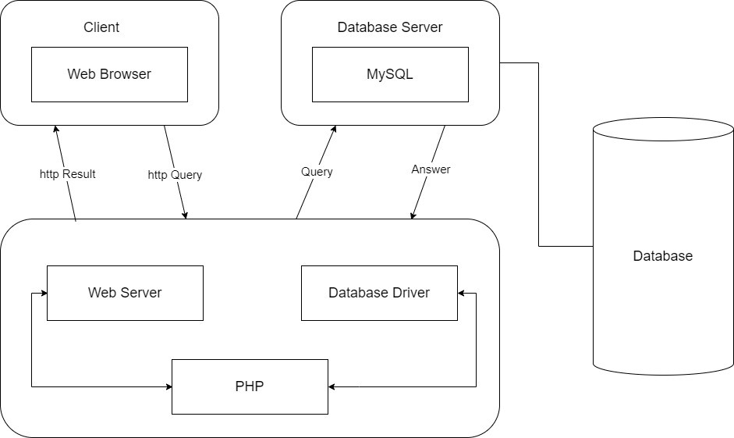

### Figure 3.7: Architectural Design

Database Schema Design

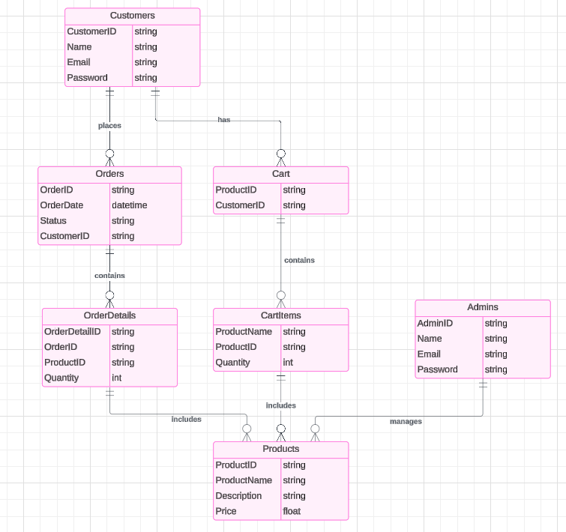

### Figure 3.8: Database Schema Diagram

### Interface Design

Interface design, commonly known as user interface (UI) design, involves creating the visual layout and interactive elements of digital products such as websites, mobile apps, and

software applications. The aim is to optimize the user experience by making interactions with the product intuitive, efficient, and enjoyable.

## Figure 3.2.2.1: User Login

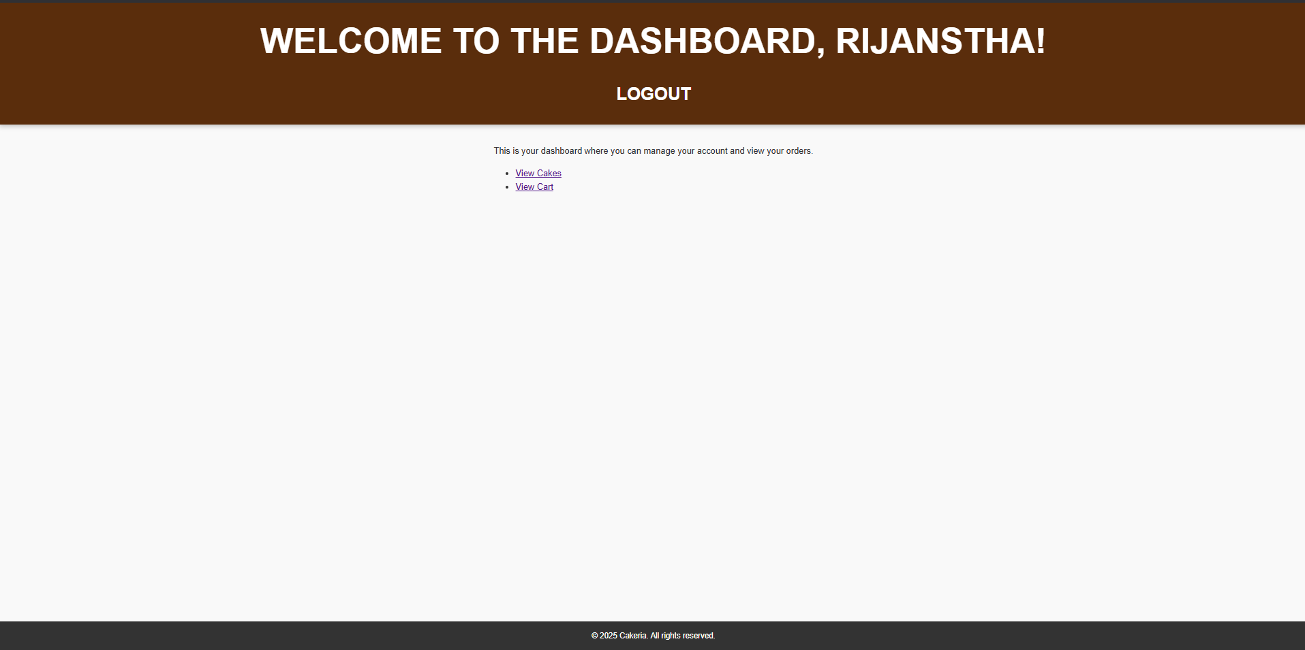

## Figure 3.2.2.2: User Dashboard

# Chapter 4: Implementation and Testing

## Implementation

The implementation phase is a crucial stage in the waterfall method, where the planned system or software solution is transformed from a conceptual design into a tangible reality.

### Tools Used

A variety of tools and technologies were used in developing both the front-end and back-end of the system. These tools are listed below:

* + - 1. **Programming Languages:**
         * **HTML (Hyper-Text Markup Language):** Used to structure the content of the web pages. HTML is universally supported by all web browsers, ensuring consistent rendering across different devices and platforms.
         * **CSS (Cascading Style Sheets):** Enhances the visual appeal and user experience of the web pages by providing a consistent and attractive design.
         * **PHP:** Used for server-side scripting. It allows for the creation of dynamic web pages that can display different content based on user interactions or other inputs. PHP also integrates easily with various databases, making it ideal for developing data-driven applications.
         * **PHP:** We have used PHP for server-side scripting because PHP allows for the creation of dynamic web pages that can display different content based on user interactions or other inputs and can easily integrate with various databases, making it ideal for developing data-driven applications and websites.
      2. **Integrated Development Environment (IDE):**
         * **VS Code (Visual Studio Code):** Chosen as the text editor due to its robust features, extensions, and a powerful debugger for coding in HTML, CSS, and PHP.
      3. **Database:**
* **MySQL**: Used to store and manage structured data. MySQL is reliable, scalable, and easy to use, making it suitable for database operations.
  + - 1. **Diagrams:**
         * Lucidchart: To create various diagrams for documentation, we have used Lucidchart, a popular online diagramming tool. It provides a wide range of templates and shapes for creating diagrams like ER Diagrams and DFDs.

### Implementation of Module

Incorporating a module into the web application entails designing and seamlessly integrating distinct features and capabilities into the digital platform. Below are the modules implemented in the project:

* + - 1. **Users Module:** The user module provides a streamlined experience for users to engage with the e-commerce platform. Key features include:
         * **Registration Process:** Users create accounts with personal credentials, which are later used to log in. Registration is facilitated through a dedicated sign-up page.
         * **Login Process:** Users authenticate their accounts using credentials (username and password) or via Google account login, redirecting to the homepage.
         * **Cart Process:** Users can add desired products to the cart or delete products from the cart.
         * **Checkout Process:** A "Checkout" button redirects users to a checkout page/form.
         * **Cancel Order Process:** Users can cancel their orders if they choose not to proceed with the purchase.
         * **Logout Process:** A logout button on the navbar destroys the session and redirects the user to the homepage.
      2. **Admin Module:** The admin module provides funtionality for managing the platform’s operation effectively. Key features include:
         * **Login Process:** Admins log in using credentials (username and password) to access the dashboard.
         * **Credentials Change**: Admins can change the admin username and password when logged in.
         * **Product Management:** Admins can add, update, or delete product listings.
         * **Order Process:** Admins can accept, reject, or mark orders as delivered.
         * **Logout Process:** A logout button on the navbar destroys the session and redirects to the login page.

## Testing

Testing is an essential phase in software development that entails assessing and verifying a software application to ensure it aligns with specified requirements, operates as intended, and is free from defects.

### Test Case for Unit Testing

Unit testing is a foundational practice within software development, focusing on examining discrete code components or units in isolation to confirm their proper operation. Below is an example test case:

**Table 4.1: User Registration and Authentication Test Cases**

|  |  |  |  |  |  |
| --- | --- | --- | --- | --- | --- |
| S.no | Test case | Input | Expected result | Actual result | Status |
| 1. | User  Registration | User provides valid  registration details  (username, email,  password) | User account is created  successfully, and they are  redirected to the login page. | User account is created  successfully, and they are  redirected to the login page. | PASS |
| 2. | User Login | User provides valid login  credentials  (username and Password). | User is  successfully  authenticated and redirected to the user dashboard. | User is  successfully  authenticated and redirected to the user dashboard. | PASS |
| 3. | Authentication Failure | User provides incorrect login credentials. | Authentication fails, and an error message is displayed. | Authentication fails, and an error message is displayed. | PASS |

**Table 4.2: Add to Cart Test Cases**

|  |  |  |  |  |  |
| --- | --- | --- | --- | --- | --- |
| S.no | Test case | Input | Expected result | Actual result | Status |
| 1. | Add to cart | User clicks on add to cart button. | The item is added to the cart. | The item is added to the cart. | PASS |
| 2. | View Cart | User clicks on cart button. | User cart’s  items are displayed. | User cart’s items are displayed. | PASS |
| 3. | Delete cart | User clicks on delete button. | User cart item is deleted. | User cart item is deleted. | PASS |

**Table 4.3: Order Test Cases**

|  |  |  |  |  |  |
| --- | --- | --- | --- | --- | --- |
| S.no | Test case | Input | Expected result | Actual result | Status |
| 1. | Create an order | User clicks on proceed to checkout button. | An order is created and the user is shown a order successful message. | An order is created and the user is shown a order successful message. | PASS |
| 2. | View order | Users click on orders button. | User is redirected to order page with list of all orders. | User is  redirected to order page with list of all orders. | PASS |
| 3. | Cancel order | Users click on cancel order button. | User is  redirected to cart page with list of all orders. | User is  redirected to cart page with list of all orders. | PASS |

**Table 4.4: Admin Order-Management Test Cases**

|  |  |  |  |  |  |
| --- | --- | --- | --- | --- | --- |
| S.no | Test case | Input | Expected result | Actual result | Status |
| 1. | Viewing a pending order | Admin clicks on manage orders button. | List of all pending orders are displayed. | List of all pending orders are displayed. | PASS |
| 2. | Complete orders | Admin clicks on Successful inside manage order. | An order is marked as successful. | An order is marked as successful. | PASS |
| 3. | Cancel orders | Admin clicks on Canceled order inside manage order. | An order is marked as canceled. | An order is marked as canceled. | PASS |
| 4. | Delete orders | Admin clicks on delete order inside manage order. | An order is deleted. | An order is deleted. | PASS |

**Table 4.5: Product-Management Test Cases**

|  |  |  |  |  |  |
| --- | --- | --- | --- | --- | --- |
| S.no | Test case | Input | Expected result | Actual result | Status |
| 1. | Add product | Admin clicks on add product  button on manage product. | A new product is added. | A new product is added. | PASS |
| 2. | Delete  product | Admin clicks on Delete product button. | A product is deleted. | A product is deleted. | PASS |
| 3. | Update product | Admin clicks on Update product button. | A product is updated. | A product is updated. | PASS |

### Test Case for System Testing

System testing is a type of software testing that evaluates the overall functionality and performance of a complete and fully integrated software solution.

**Table 4.6: Session Test Cases**

|  |  |  |  |  |  |
| --- | --- | --- | --- | --- | --- |
| S.N. | Test Case Description | Input | Expected Result | Actual Result | Pass / Fail |
| 1 | Verify user  registration with valid details. | Valid details | User is  registered  successfully. | User is  registered  successfully. | PASS |
| 2 | Verify that valid credentials  allow the user to log in | Valid  credentials | User is logged in | User is logged in | PASS |
| 3 | Verify that invalid credentials  result in an error message | Invalid  credentials | Error message is  displayed | Error message is  displayed | PASS |
| 4 | Verify that all the  buttons on the home page work  as expected | Click all Buttons | All the buttons work as  expected | All the buttons work as  expected | PASS |
| 5 | Verify that the user can add the quantity of chosen cake in to their cart and place order. | Cake: Black Forest Quantity: 1 Users click add to cart and checkout. | Item added to cart and order placed | The item is added to cart and order is placed | PASS |
| 6 | Verify that order can be Cancelled. | User presses cancel  button. | The order is cancelled. | The order is cancelled. | PASS |
| 7 | Verify that a new product can be  added. | New cake details. | Cake added successfully. | Cake added successfully. | PASS |
| 8 | Verify that a product can be edited. | New cake details. | Cake is Edited. | Cake is Edited. | PASS |
| 9 | Verify that a product can be deleted. | Click delete product button | The cake is removed from the database. | The cake is removed from the database. | PASS |
| 10 | Verify that order can be completed. | Admin clicks successful button. | The order is completed. | The order is completed. | PASS |

|  |  |  |  |  |  |
| --- | --- | --- | --- | --- | --- |
| 11 | Verify that order can be Cancelled. | User presses cancel  button. | The order is cancelled. | The order is cancelled. | PASS |

# Chapter 5: Conclusion and Future Recommendation

## Lesson Learnt and Outcome

**Lesson Learnt:**

* Gained proficiency in full-stack web development, including both front-end and back-end technologies.
* Acquired expertise in using HTML and CSS for crafting the website’s frontend, ensuring a visually appealing and responsive design.
* Understood the importance of PHP for server-side scripting and its role in seamless database connectivity.
* Learned about relational database management, particularly MySQL, and its effective use for handling structured data.
* Familiarized with testing methodologies like unit testing and system testing, ensuring a bug-free and efficient system.
* Developed the skill of creating thorough documentation to facilitate future troubleshooting and potential system expansion.

This project provided a comprehensive learning experience in web development and system implementation for "Cakeria," preparing the team for future challenges in similar domains.

**Outcome:**

The "Cakeria" project successfully developed an online platform that streamlines the cake ordering process for both customers and administrators. Admins can efficiently manage product listings by adding, updating, and deleting cakes, as well as tracking and managing customer orders. The admin dashboard provides an overview of orders and product inventory, ensuring smooth operations.

Customers can browse the available products, add multiple cakes to their cart, and complete their orders through a simple and intuitive interface. Additionally, customers can monitor the status of their orders and cancel them if needed. The project ensures a seamless and user-friendly experience for both customers and administrators, effectively enhancing the cake ordering and management process.

## Conclusion

Cakeria is more than just a cake ordering system; it’s a platform that brings joy, celebration, and meaningful connections to people’s lives. Beyond the immediate convenience for customers, Cakeria enhances the way we celebrate life's milestones by making the process of ordering cakes simple and delightful.

Ordering from Cakeria means having access to a variety of cakes tailored to every occasion, from birthdays to anniversaries. It fosters a sense of community by connecting customers to beautifully crafted cakes that bring happiness to every gathering. Furthermore, Cakeria supports local bakeries by providing them with a platform to reach a wider audience and manage their operations efficiently.

With a user-friendly interface, seamless order tracking, and a dedicated admin dashboard, Cakeria ensures a smooth experience for everyone involved. Each order placed through Cakeria contributes to making celebrations more memorable and accessible, creating a world where every special moment is cherished and shared.

## Future Recommendations

As part of the continuous improvement and scalability of Cakeria, the following recommendations are suggested for future development:

* Implement Cake Customization Features: Allow customers to customize cakes by selecting flavors, sizes, designs, and personalized messages.
* Add Stock Management System: Enable real-time tracking of product inventory to prevent overselling and ensure timely restocking.
* Integrate Payment Gateways: Incorporate secure online payment options like credit/debit cards, mobile wallets, and UPI for a smoother transaction process.
* Enhance Order Tracking: Provide customers with live updates on the status of their orders, including preparation, dispatch, and delivery stages.
* Mobile Application Development: Build a mobile app for Cakeria to make the platform accessible on-the-go and enhance the user experience.
* Introduce Customer Reviews: Add a feature for customers to rate and review cakes and services, building trust and improving service quality.
* Multilingual Support: Provide language options to cater to a diverse user base, ensuring better accessibility.
* Advanced Analytics for Admins: Offer detailed sales reports, customer insights, and performance metrics to assist admins in strategic decision-making.
* Subscription Plans: Introduce subscription options for regular customers with benefits like discounts or free delivery.
* Expand Delivery Options: Collaborate with delivery services to expand the delivery radius and improve order fulfillment speed.

These enhancements can help make Cakeria more versatile, efficient, and appealing to both customers and administrators, ensuring its long-term success and growth.

## Appendices



### Figure 1: Admin Login

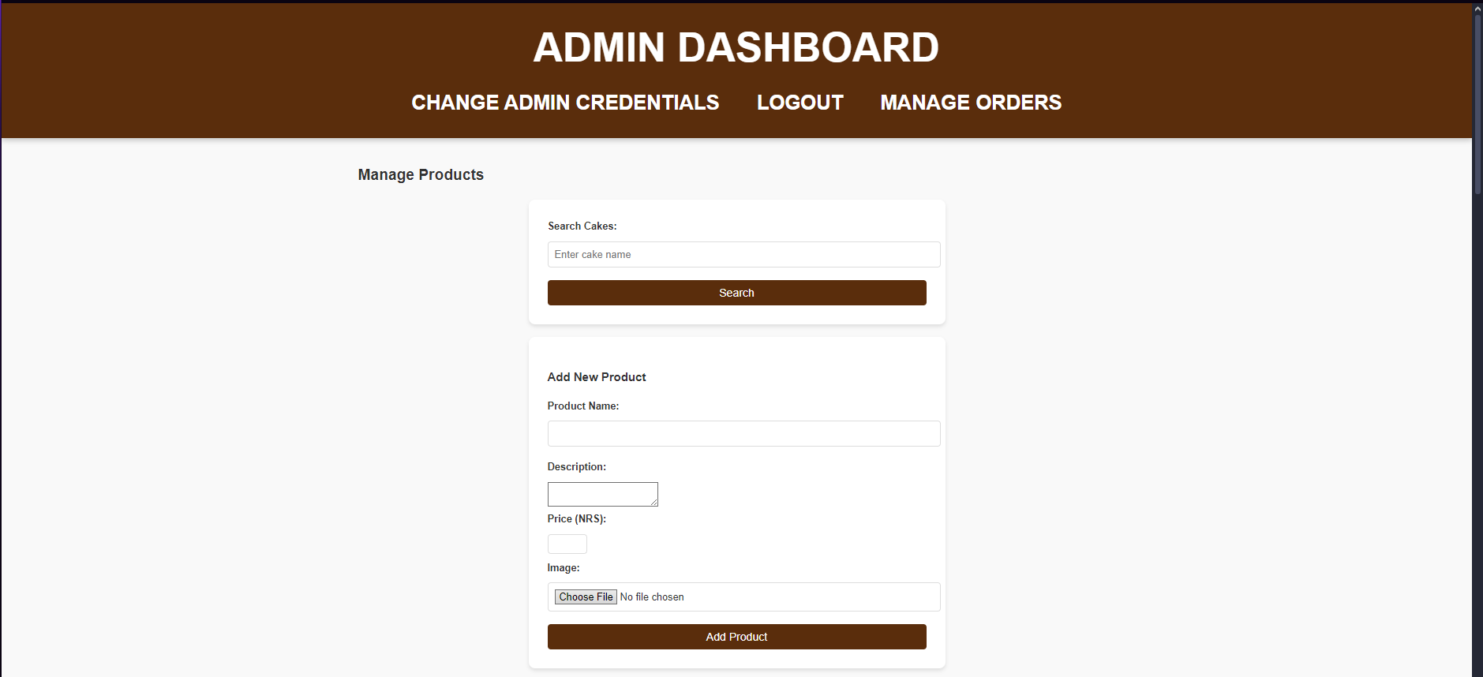

### Figure 2: Admin Dashboard

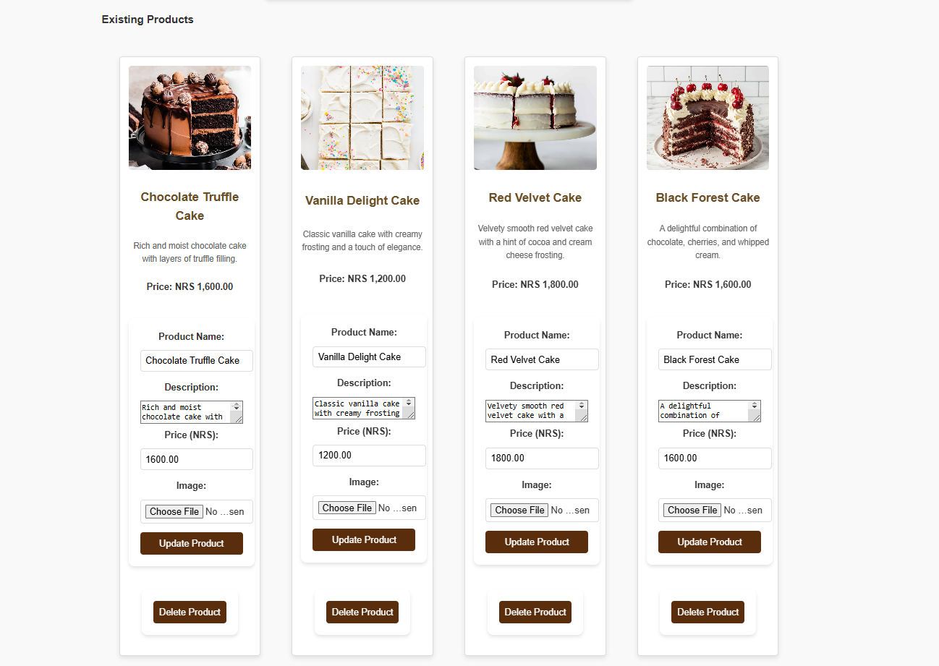

### Figure 3: Admin Manage Products

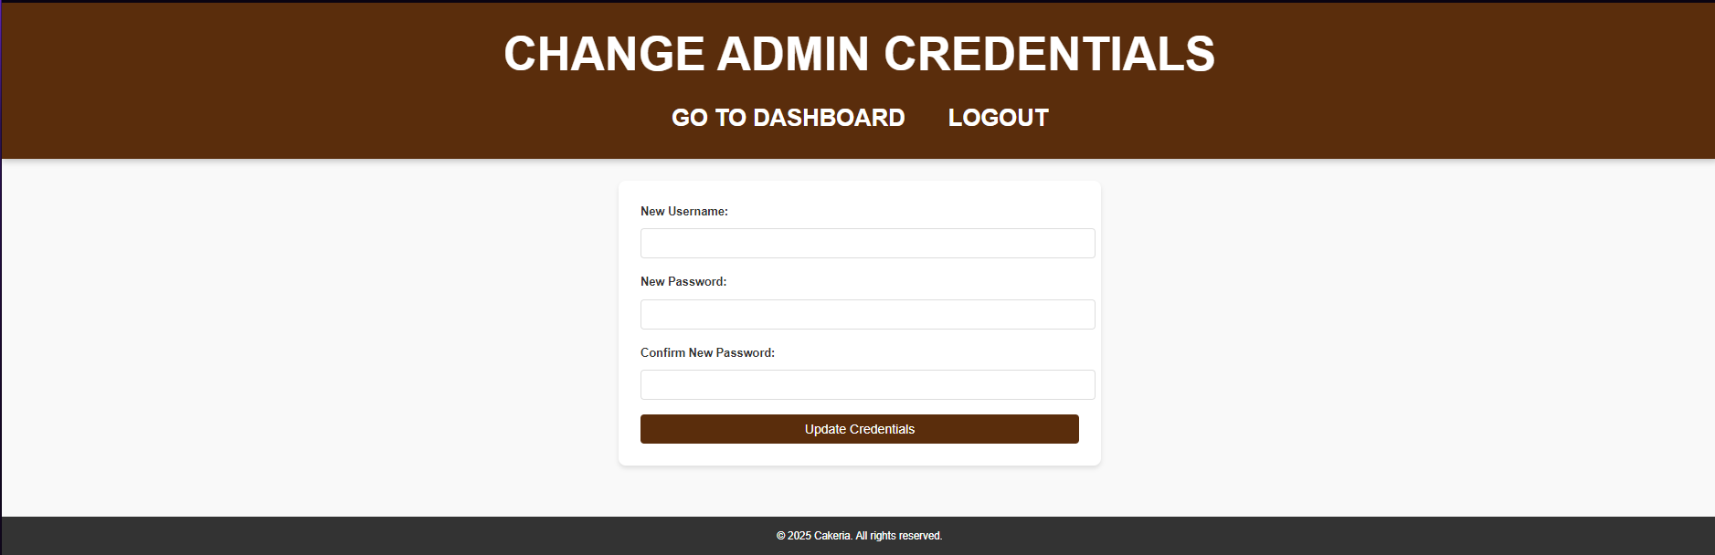

### Figure 4: Admin Change Credentials

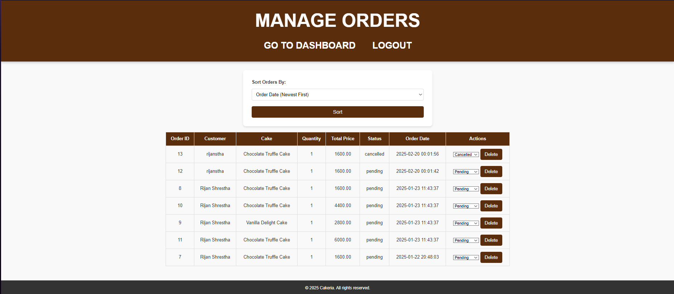

### Figure 5: Admin Manage Orders

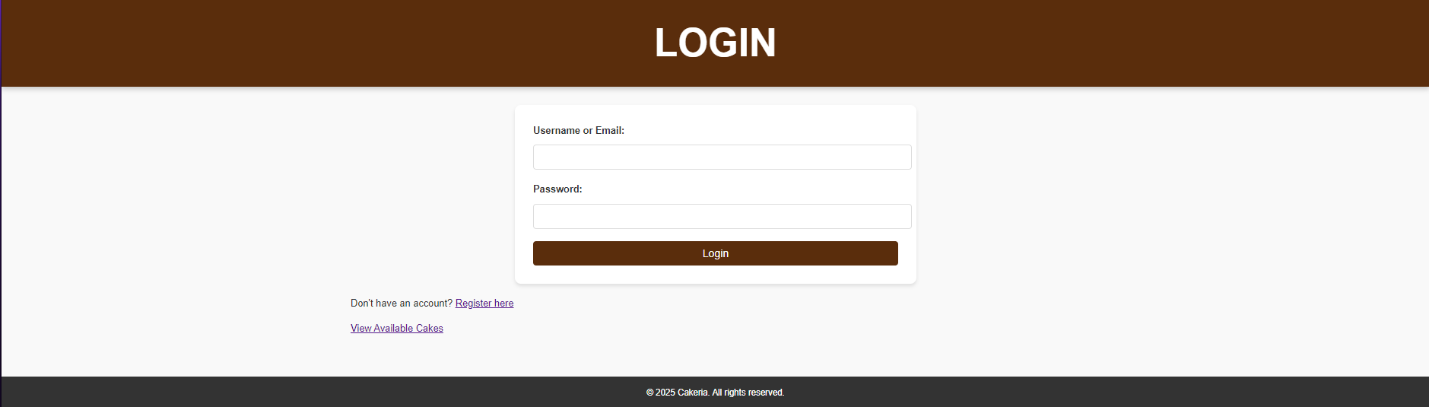

### Figure 6: User Login

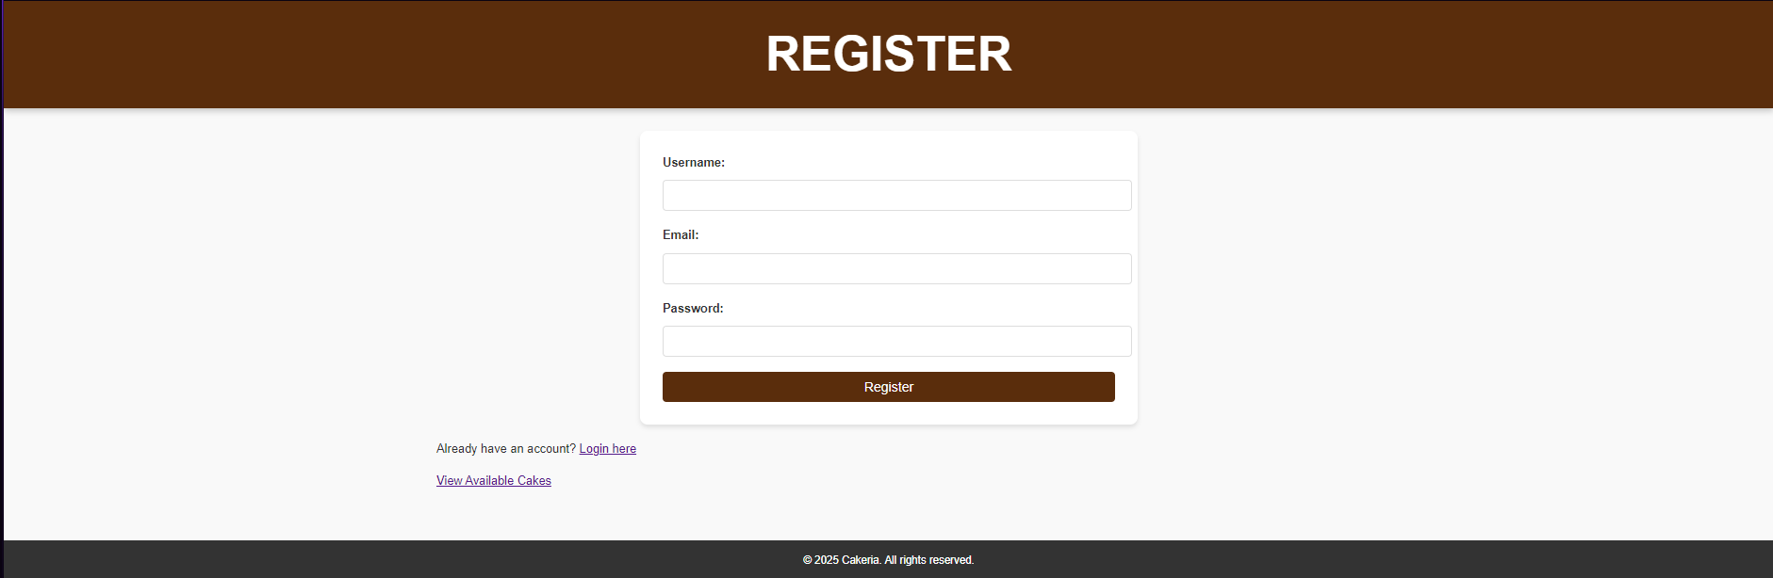

### Figure 7: User Register



### Figure 8: User Dashboard

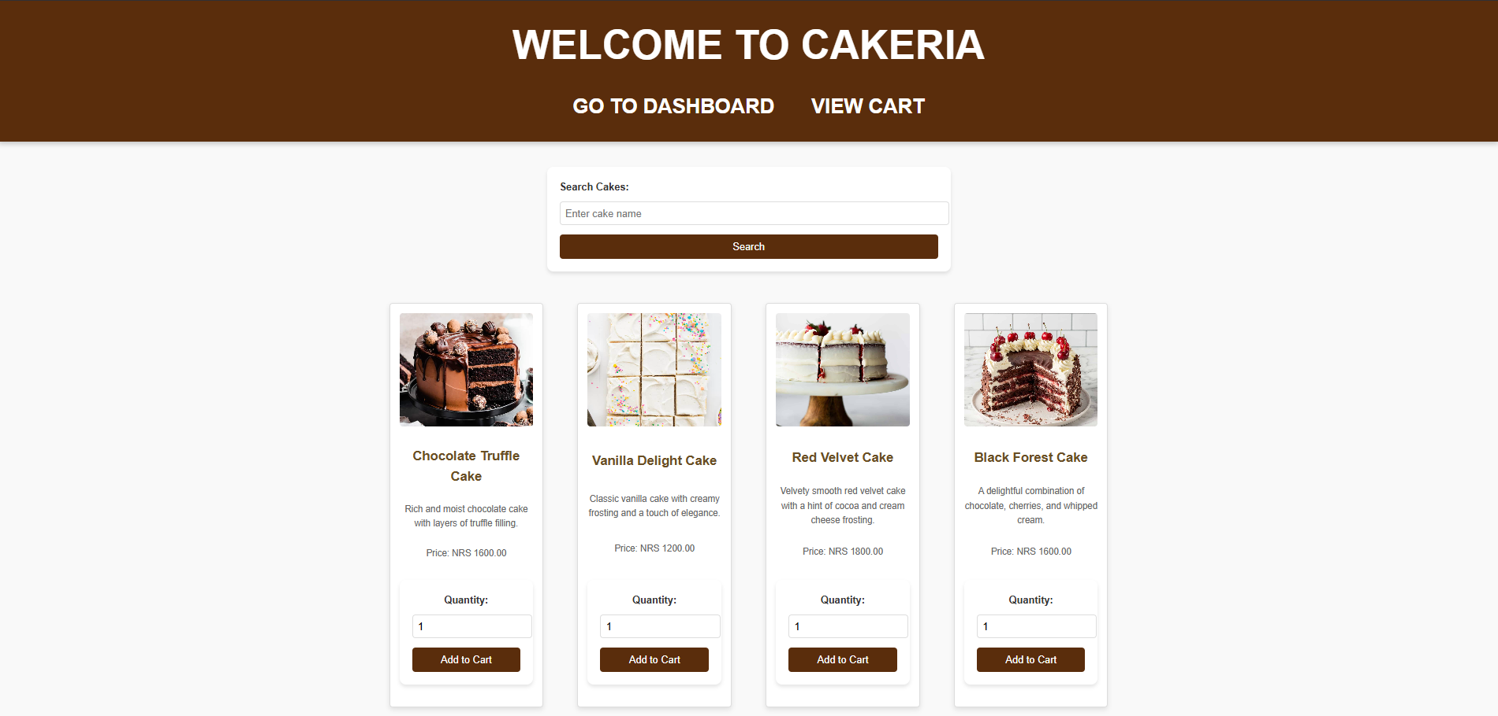

### Figure 9: User View Products

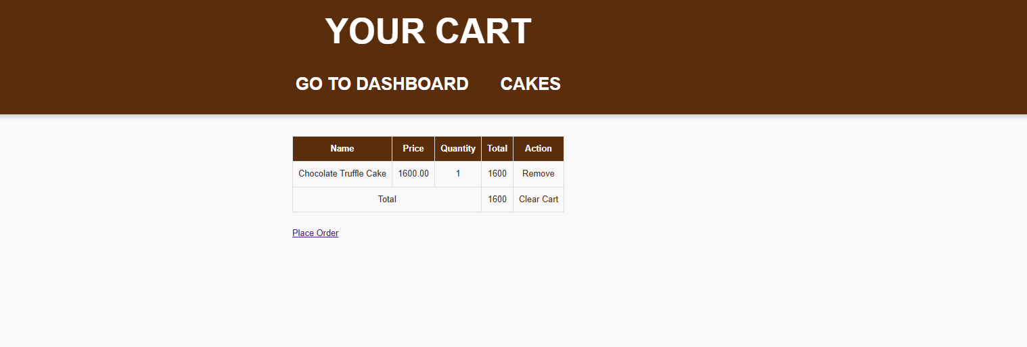

### Figure 10: User Cart

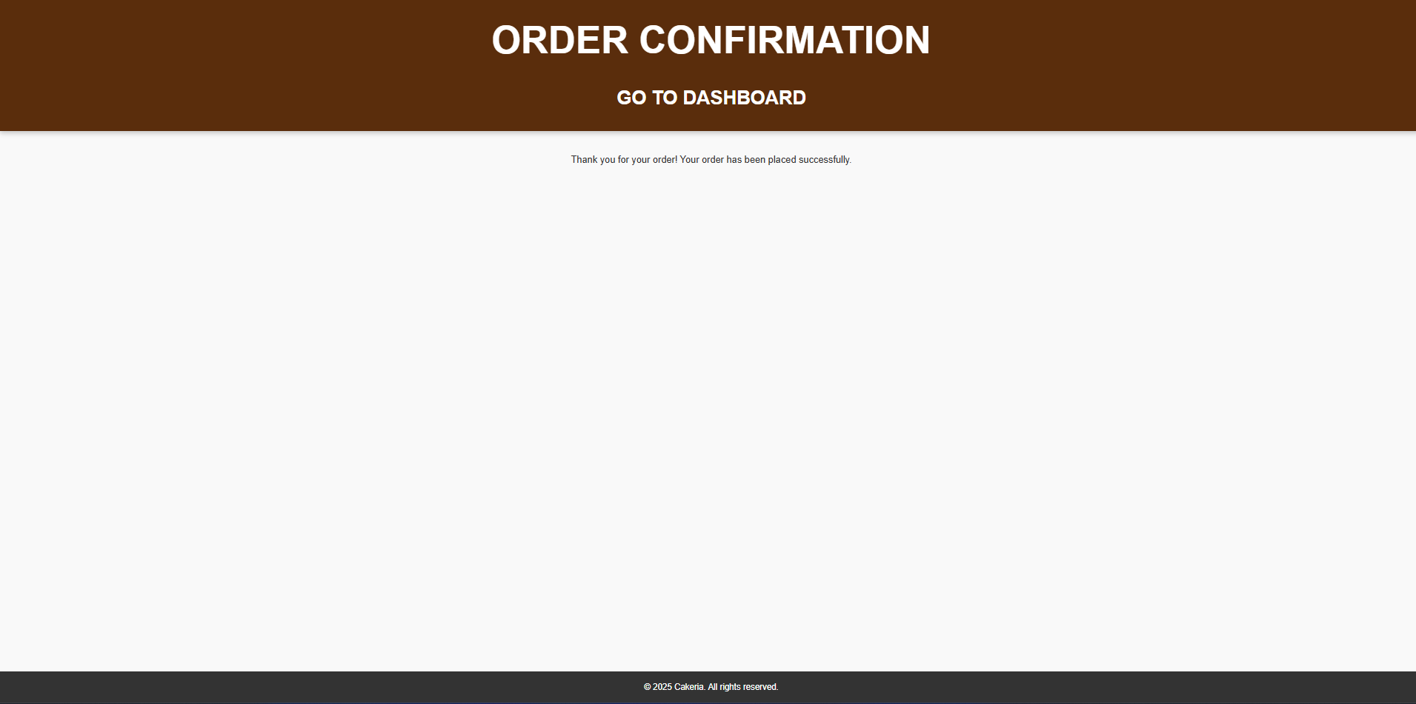

### Figure 11: User Order Confirmation

# References

* M. Smith, "Online Cake Ordering System," Journal of Applied IT, vol. 25, no. 7, 2023.
* J. Doe, "Custom Cake Ordering Application," Journal of Food Commerce, no. 16-12-2022, pp. 45-50, 2022.
* D. Nguyen, "Managing Cake Orders Online," E-commerce Journal, vol. 10, no. 5, pp. 120-125, 2021.